**Impact of GM, ARPU and churn rate on LTV for medium and small size subscription businesses**

A Monte Carlo simulation has been performed to analyse the LTV and how it is affected by different factors such as GM, ARPU and churn rate. The simulation was performed in the attached python file in which you will find the following content:

Two identical functions LTV and LTV_short_code. They both take the ARPU, GM, monthly churn rate and number of customers as input parameters and return the average LTV of a customer. The first one is a more intuitive one and I also commented a lot on it to make it easier for you to understand what is going on. The second one is to show you how the same thing can be coded faster if you are interested in learning about python(otherwise ignore it).

Next, like we discussed, two groups of customers were taken into account. A small-sized subscription business with ARPU of 300$ and a medium-sized business with ARPU of 700$. You mentioned you wanted to research how different GM and churn rates affect the LTV, so I generated two tables with LTVs that were calculated using GMs between 45% and 60% and monthly churn rates between 1% and 10%. Below is the table for the small-sized business.

|  |  |  |  |  |
| --- | --- | --- | --- | --- |
|  | **GM** | | | |
| Churn rate | **45%** | **50%** | **55%** | **60%** |
| **1.0%** | 13683 | 15461 | 16021 | 18239 |
| **2.0%** | 6489 | 7705 | 7836 | 8832 |
| **3.0%** | 4418 | 5145 | 5111 | 6218 |
| **4.0%** | 3289 | 3904 | 4012 | 4494 |
| **5.0%** | 2743 | 3040 | 2972 | 3575 |
| **6.0%** | 2171 | 2475 | 2721 | 2865 |
| **7.0%** | 2046 | 2149 | 2358 | 2565 |
| **8.0%** | 1683 | 1819 | 2167 | 2173 |
| **9.0%** | 1553 | 1623 | 1957 | 1993 |
| **10.0%** | 1308 | 1473 | 1623 | 1812 |

Similarly for the medium-sized company:

|  |  |  |  |  |
| --- | --- | --- | --- | --- |
|  | **GM** | | | |
| Churn rate | **45%** | **50%** | **55%** | **60%** |
| **1.0%** | 29947 | 34813 | 39186 | 41653 |
| **2.0%** | 16257 | 18054 | 18436 | 21004 |
| **3.0%** | 11238 | 11583 | 12768 | 14608 |
| **4.0%** | 8107 | 9061 | 9119 | 10294 |
| **5.0%** | 6662 | 6874 | 7656 | 8830 |
| **6.0%** | 5279 | 5915 | 6195 | 7031 |
| **7.0%** | 4517 | 4818 | 5576 | 6126 |
| **8.0%** | 4057 | 4226 | 4713 | 5299 |
| **9.0%** | 3697 | 3960 | 4404 | 4451 |
| **10.0%** | 3168 | 3434 | 3670 | 4281 |

To illustrate the effects of GM better, the LTV was plotted for a fixed churn rate of 2% and ARPU of 700 $ (so for a medium-sized business).

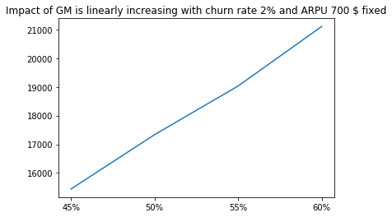

We can see that the effect of gross margin on the lifetime value of the customer is linear. So obviously, the bigger the gross margin the more value the customer brings in over the time he is subscribed and this effect is linear.

Below is a visual representation of how churn rate impacts the LTV.

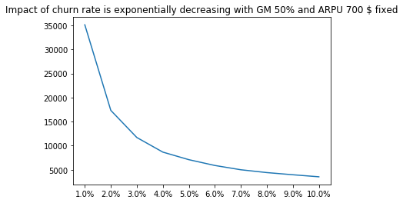

The effect here is considerably more important in my view. An increase of churn rate exponentially decreases the lifetime value of a customer, so when calculating LTV it is crucial to predict the future churn rate correctly if we want to measure the LTV accurately.

Next in the code, you will find how LTV of a single customer is distributed across its possible values. And again this was done for the small and medium size businesses(Like you mentioned in the email the ARPU is 300$ for small and 700$ for medium and churn rate is 2% for small and 1% for medium sized, whereas the GM is 50% in both instances. Below are the histograms which represent the distribution of the LTV.

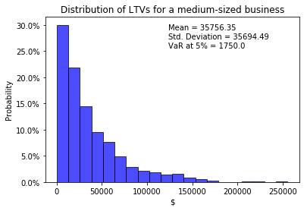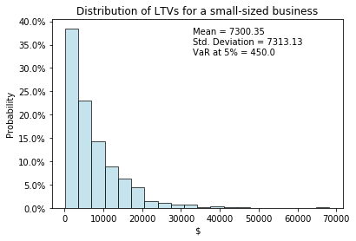

In both cases the LTV is distributed exponentially. So a big ratio of customers will generate a smaller revenue than an average one, but there are a few customers that are really loyal. But this interpretation is useful only under this simplistic case with assumption that each customer generates equal amount of revenue each month and that they all have the same churn rate.